Chapter 12, Problem 60.

Use PSpice to determine I_{o} in the single-phase, three-wire circuit of Fig. 12.66. Let Z₁ = 15 - j10 Ω, Z₂ = 30 + j20 Ω, and Z₃ = 12 + j5 Ω.

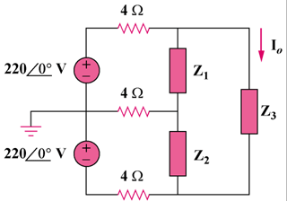

Figure 12.66
For Prob. 12.60.

